**DAY 5 - TESTING, ERROR HANDLING, AND BACKEND INTEGRATION REFINEMENT**

**Steps for Implementation:**

**Step 1: Functional Testing:**

1. Test Core Features:

Product listing: Ensure products are displayed correctly.

Filters and search: Validate accurate results based on user inputs.

Cart operations: Add, update, and remove items from the cart.

Dynamic routing: Verify individual product detail pages load correctly.

ScreenShot:

**Fetching API for product listing.and successfully done**

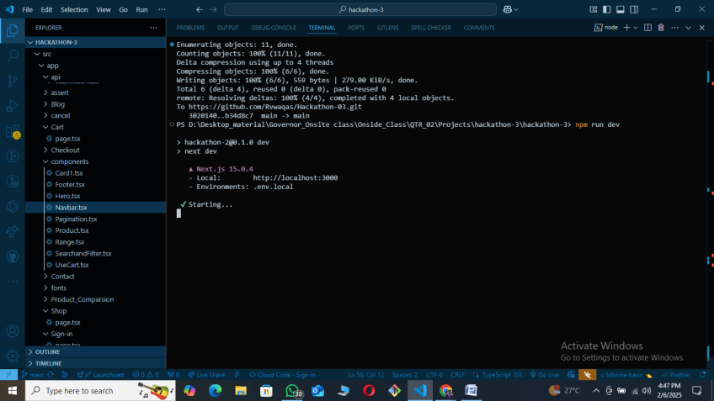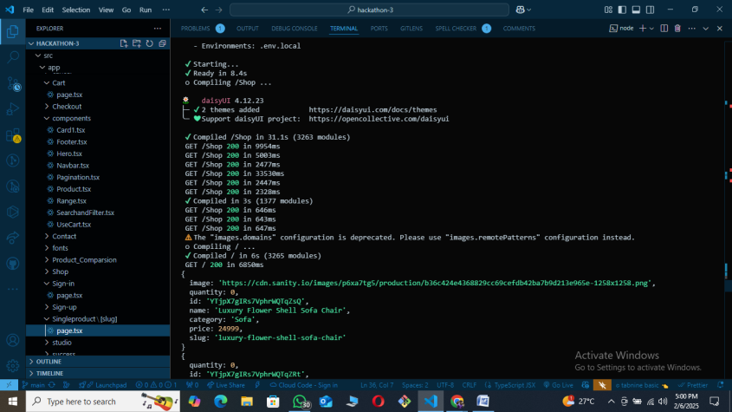

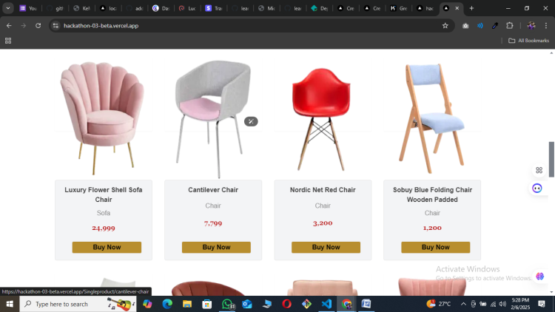

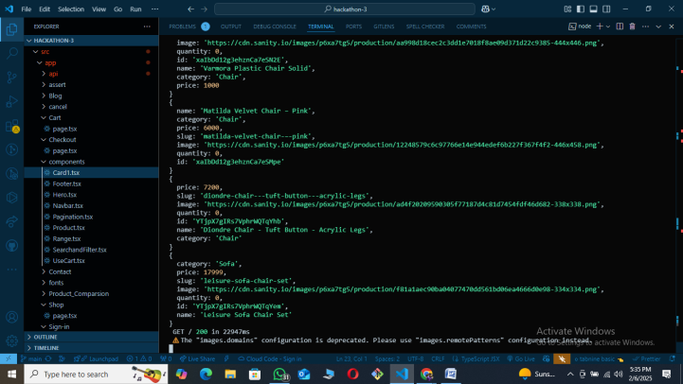

**Now contact form post data to sanity.**

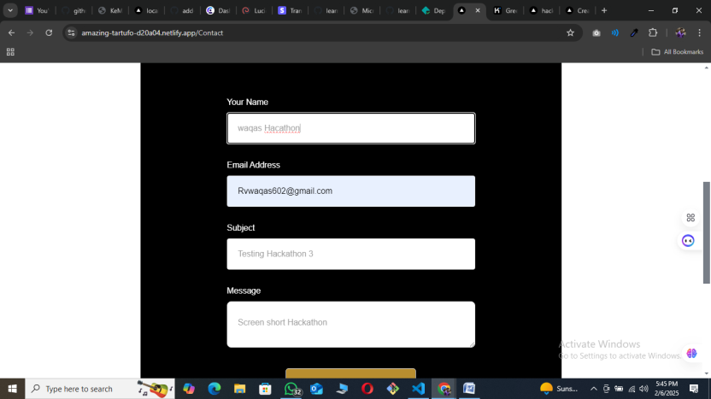

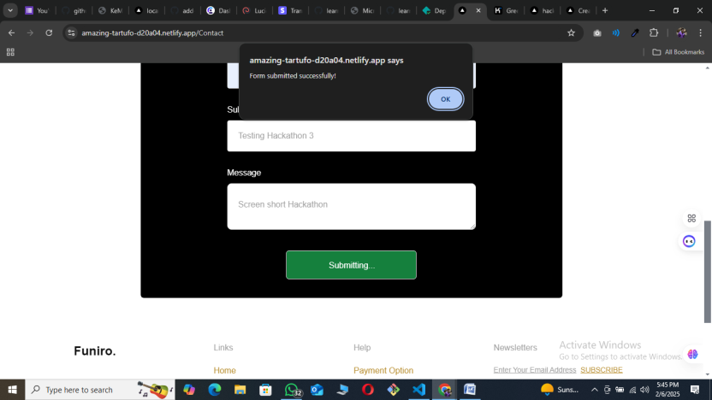

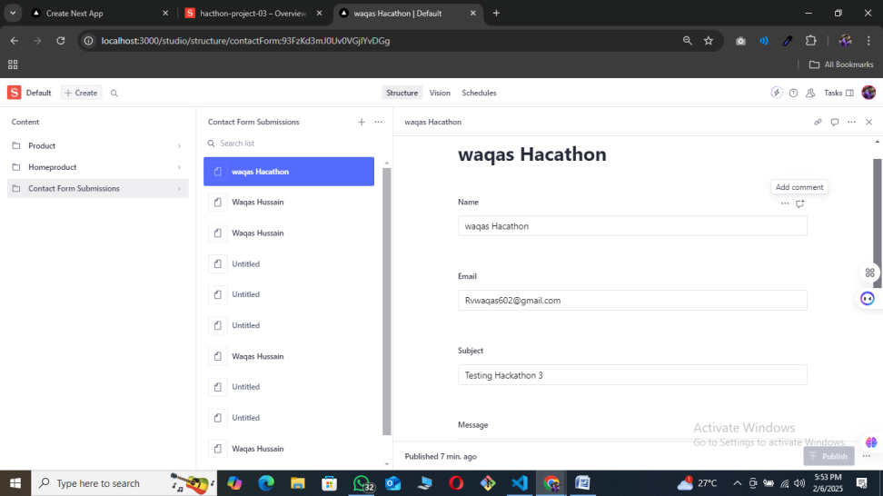

**Contact form data save in sanity sucessfully.**

**SignIn Signup functionailty succcessfully done.**

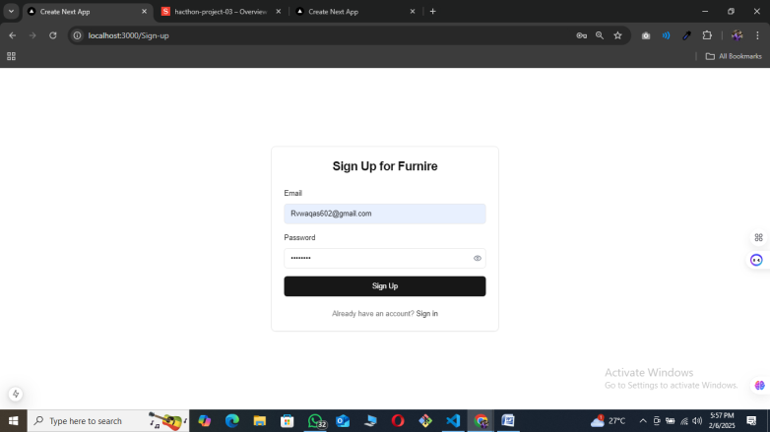

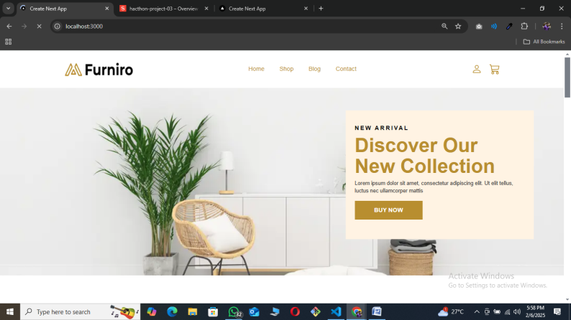

**Add to cart successfully done**

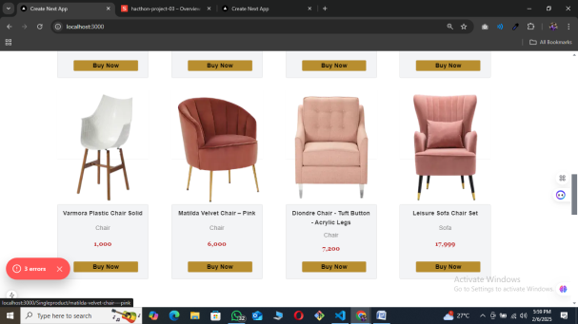

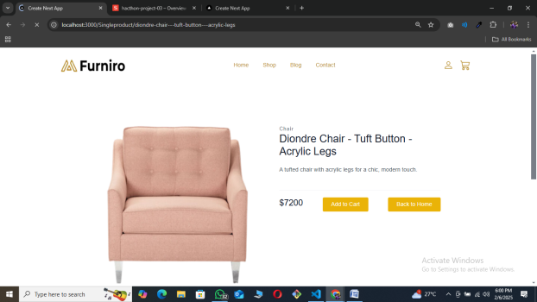

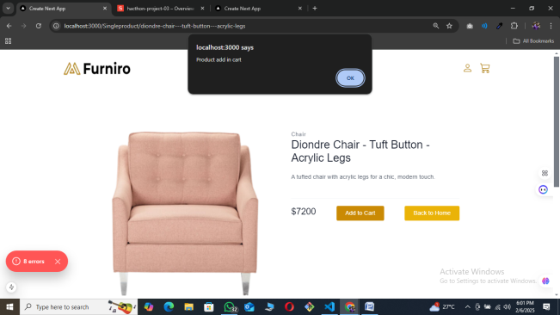

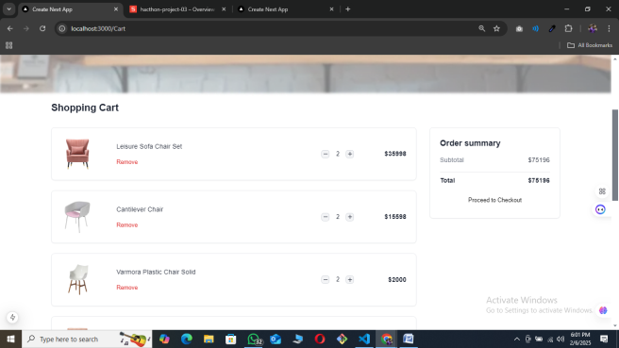

**Payment gatewat successfully done.  
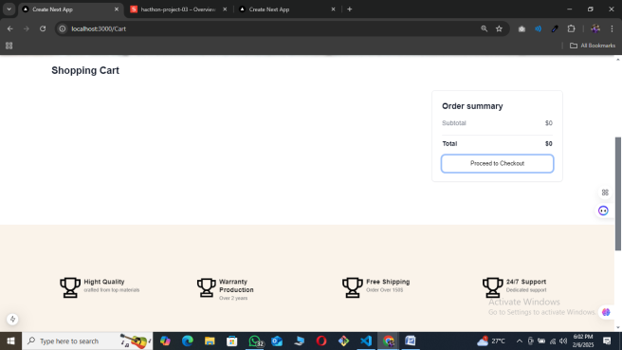**

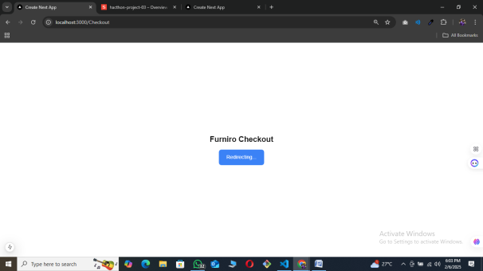

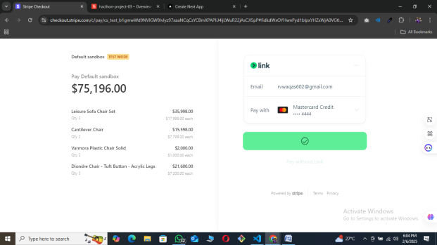

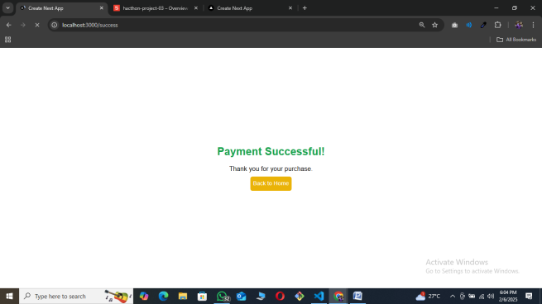

**API Get result from postman  
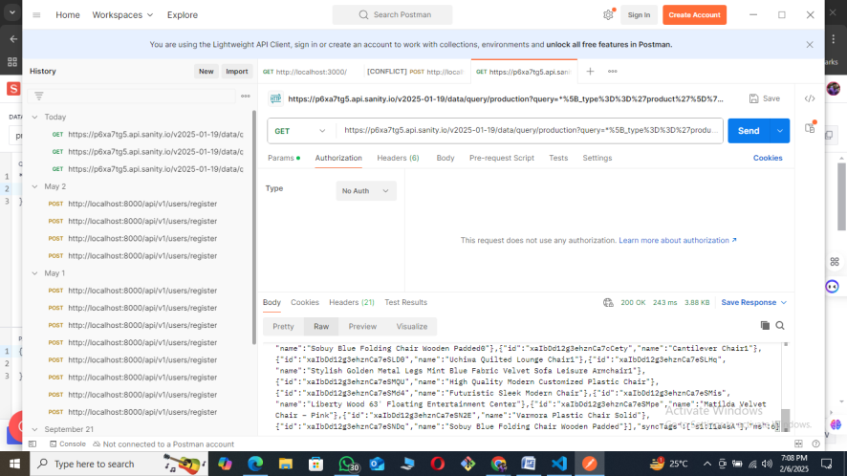**

**Cross platform Show perfect results:**

**Microsoft Edge**

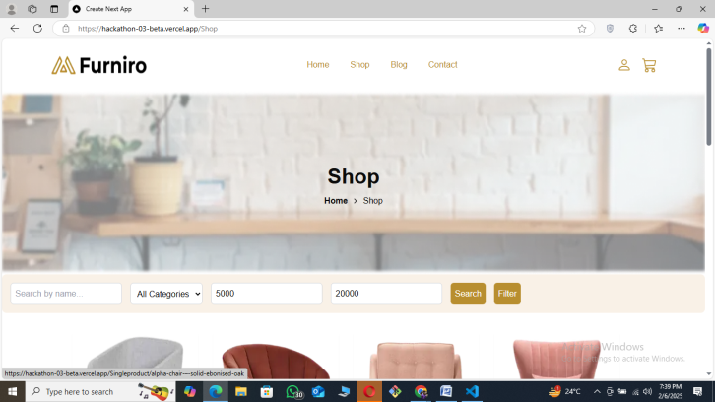

**Chrome:**

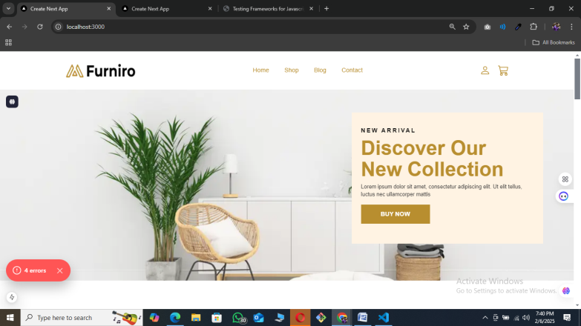

**Here are the test case tables for the specified scenarios**:

## Test Summary

This report provides a detailed overview of the test execution results for the following modules: Signup Form, Add to Cart, Payment Method, and Responsiveness. The tests were conducted to ensure the functionality, usability, and reliability of the application across different scenarios and devices.

**Signup Form**

|  |  |  |  |  |  |  |  |  |  |  |  |  |  |  |  |  |  |  |  |  |  |  |  |  |  |  |  |  |  |  |  |  |  |  |  |  |
| --- | --- | --- | --- | --- | --- | --- | --- | --- | --- | --- | --- | --- | --- | --- | --- | --- | --- | --- | --- | --- | --- | --- | --- | --- | --- | --- | --- | --- | --- | --- | --- | --- | --- | --- | --- | --- |
| |  |  |  |  |  |  |  |  |  | | --- | --- | --- | --- | --- | --- | --- | --- | --- | | **Test Case ID** | **Test Case Description** | **Test Steps** | **Expected Result** | **Actual Result** | **Status** | **Severity Level** | **Assigned To** | **Remarks** | | TC001 | Validate signup form with valid credentials | Open signup page > Enter valid details > Submit | User registered successfully | User registered successfully | Passed | Low | - | No issues found | | TC002 | Test signup form with invalid email | Open signup page > Enter invalid email > Submit | Error message displayed | Error message displayed | Passed | Medium | - | Handled gracefully | | TC003 | Check  Same Email enter | Open signup page > Enter email address> Submit | Error message displayed | Error message displayed | Passed | High | - | Works as expected | |

**Add to Cart**

|  |  |  |  |  |  |  |  |  |
| --- | --- | --- | --- | --- | --- | --- | --- | --- |
| **Test Case ID** | **Test Case Description** | **Test Steps** | **Expected Result** | **Actual Result** | **Status** | **Severity Level** | **Assigned To** | **Remarks** |
| TC004 | Validate add to cart functionality | Open Shop page > Click product > click add to cart | Cart updates with added product | Cart updates as expected | Passed | High | - | Works as expected |
| TC005 | Test add to add or subtract product | Open cart page > click on plus > Verify cart content update | Error Cart updates correctly | Error Cart updates correctly | Passed | Medium | - | Handled gracefully |
| TC006 | Check cart update on product removal | Open cart page > Remove product > Verify cart contents | Cart updates correctly | Cart updates correctly | Passed | Low | - | No issues found |

**Payment Method**

|  |  |  |  |  |  |  |  |  |  |  |  |  |  |  |  |  |  |  |  |  |  |  |  |  |  |  |  |  |  |  |  |  |  |  |  |  |
| --- | --- | --- | --- | --- | --- | --- | --- | --- | --- | --- | --- | --- | --- | --- | --- | --- | --- | --- | --- | --- | --- | --- | --- | --- | --- | --- | --- | --- | --- | --- | --- | --- | --- | --- | --- | --- |
| |  |  |  |  |  |  |  |  |  | | --- | --- | --- | --- | --- | --- | --- | --- | --- | | **Test Case ID** | **Test Case Description** | **Test Steps** | **Expected Result** | **Actual Result** | **Status** | **Severity Level** | **Assigned To** | **Remarks** | | TC007 | Validate payment with valid credit card | Open checkout page > Enter valid credit card details > Submit | Payment successful | Payment successful | Passed | High | - | Works as expected | | TC008 | Test payment with invalid credit card | Open checkout page > Enter invalid credit card details > Submit | Error message displayed | Error message displayed | Passed | Medium | - | Handled gracefully | | TC009 | Check payment with Stride | Open checkout page > Select PayPal > Complete payment | Payment successful | Payment successful | Passed | Low | - | No issues found | |

**Responsiveness**

|  |  |  |  |  |  |  |  |  |
| --- | --- | --- | --- | --- | --- | --- | --- | --- |
| **Test Case ID** | **Test Case Description** | **Test Steps** | **Expected Result** | **Actual Result** | **Status** | **Severity Level** | **Assigned To** | **Remarks** |
| TC010 | Ensure responsiveness on mobile | Resize browser window to mobile size > Check layout | Layout adjusts properly to screen size | Responsive layout working as intended | Passed | Medium | - | Test successful |
| TC011 | Test responsiveness on tablet | Resize browser window to tablet size > Check layout | Layout adjusts properly to screen size | Responsive layout working as intended | Passed | Low | - | No issues found |
| TC012 | Check responsiveness on desktop | Resize browser window to desktop size > Check layout | Layout adjusts properly to screen size | Responsive layout working as intended | Passed | High | - | Works as expected |

**­Conclusion :**

All test cases were executed successfully with no failures. The application performed as expected across all tested functionalities. No critical issues were found, and all scenarios were handled gracefully.

**Performance Optimization:**

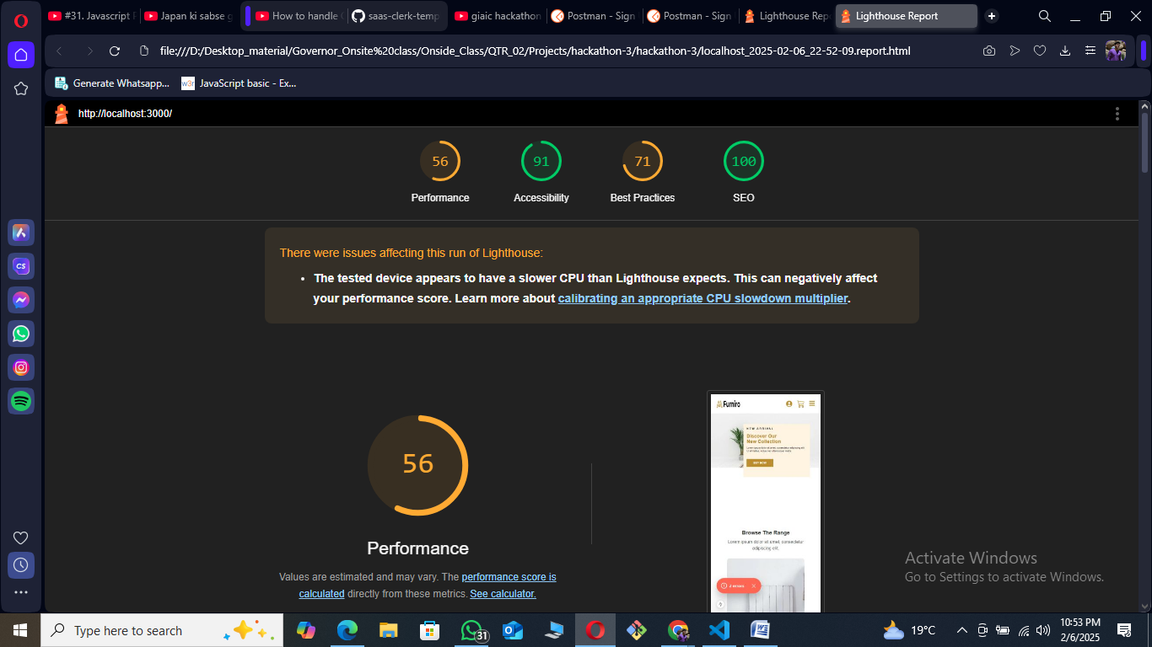

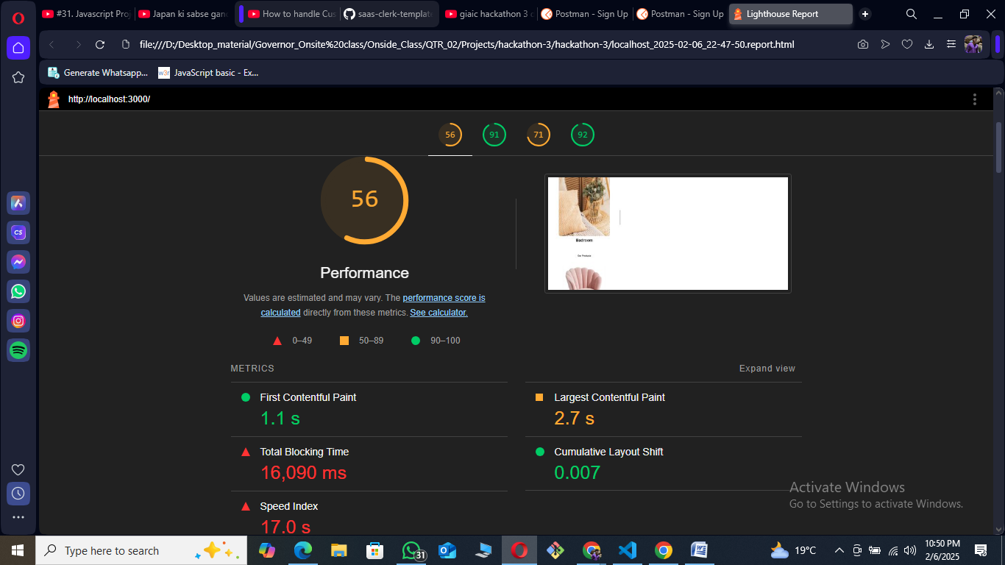

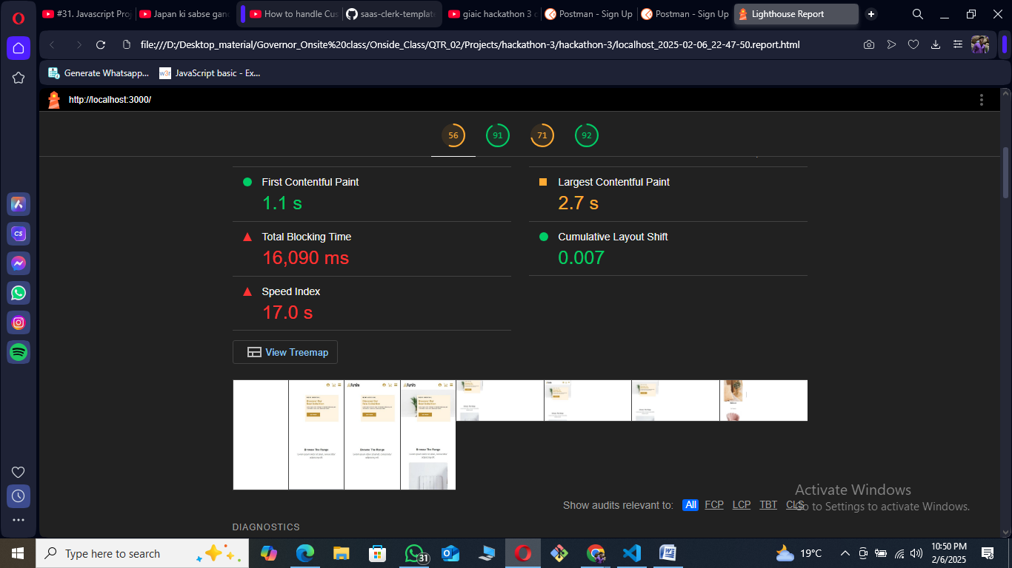

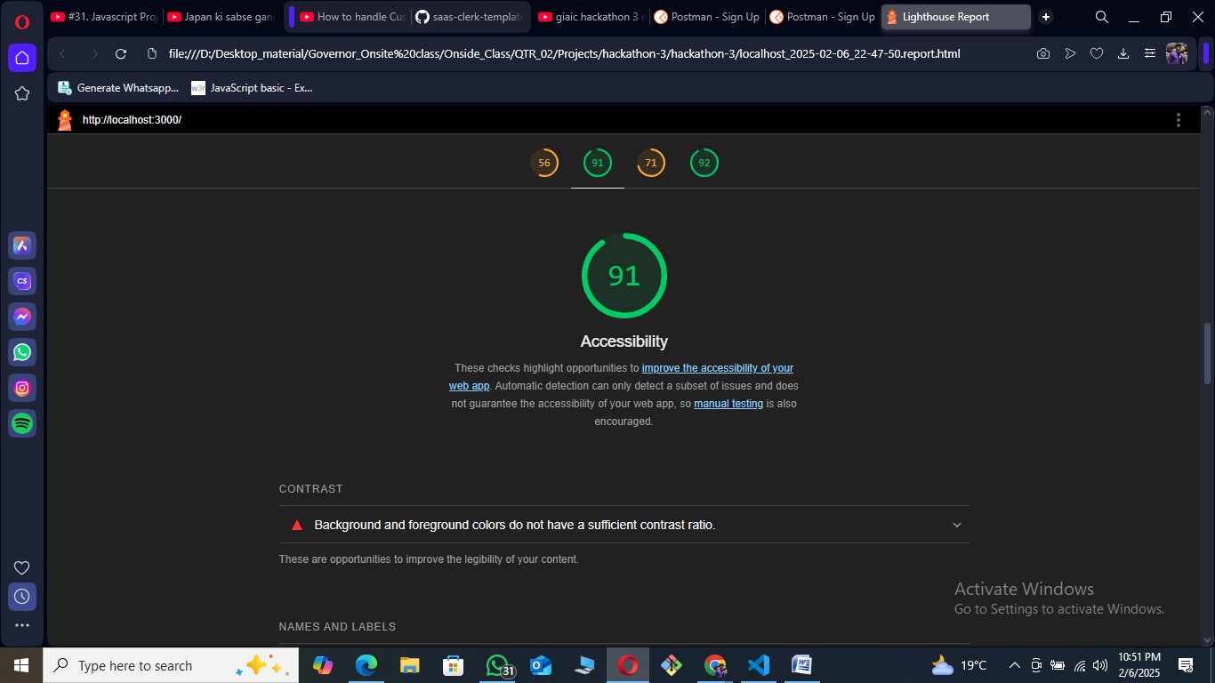

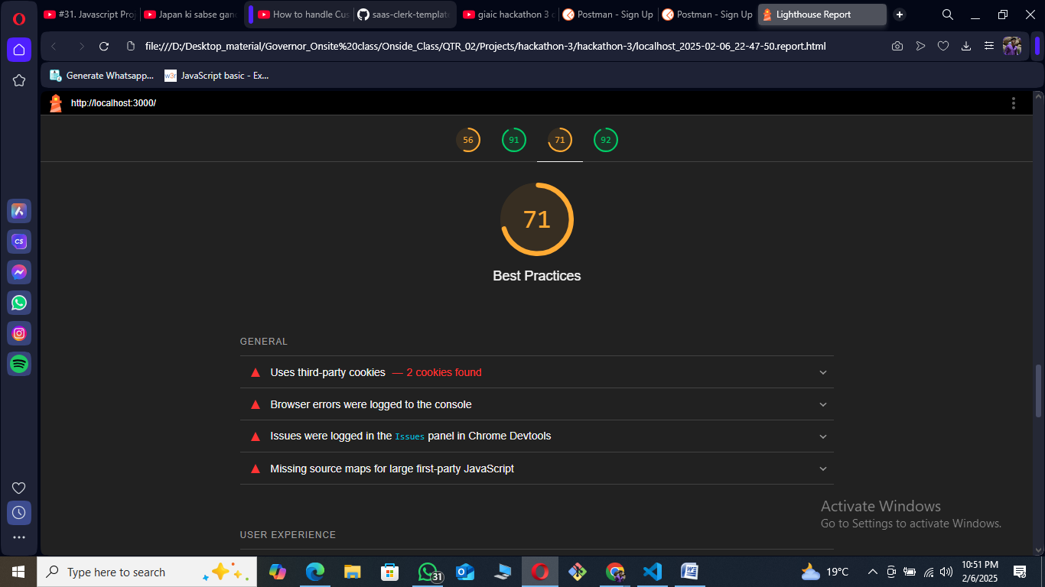

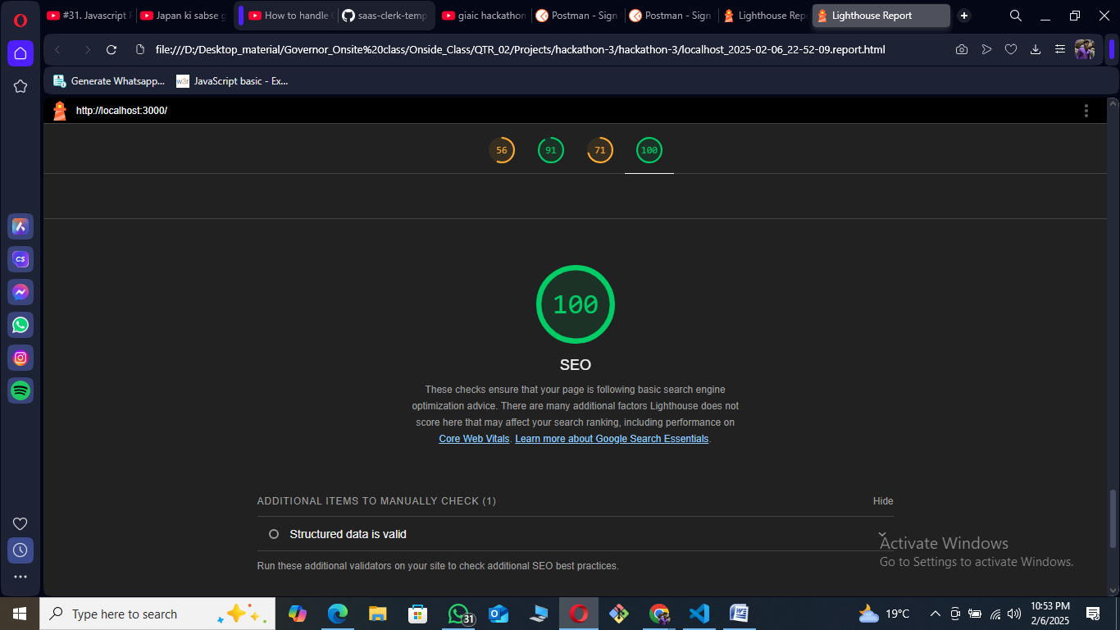

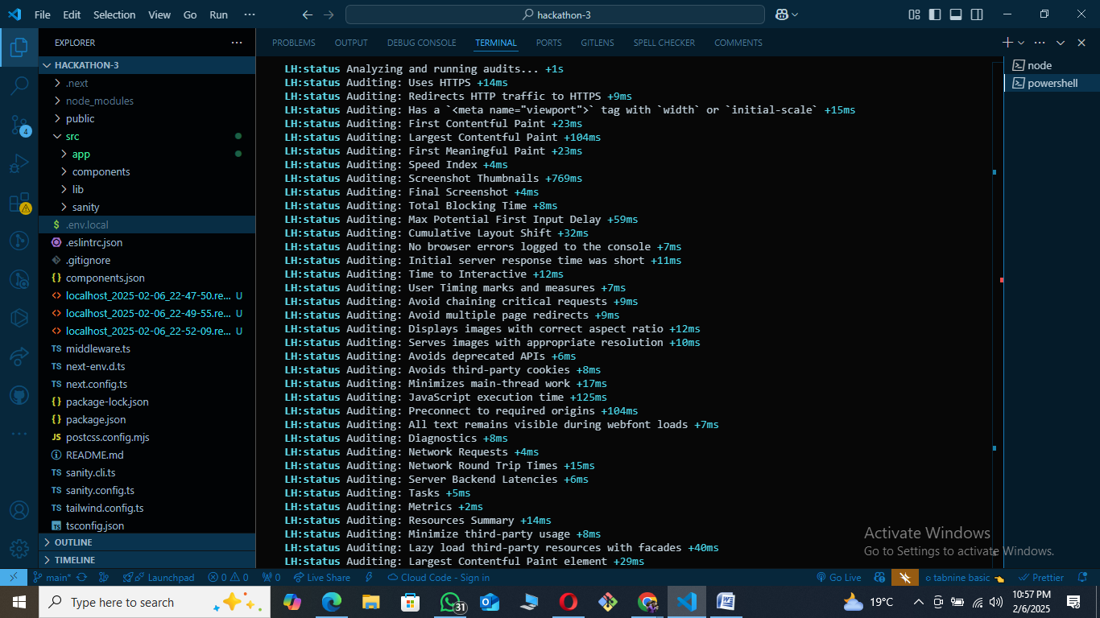

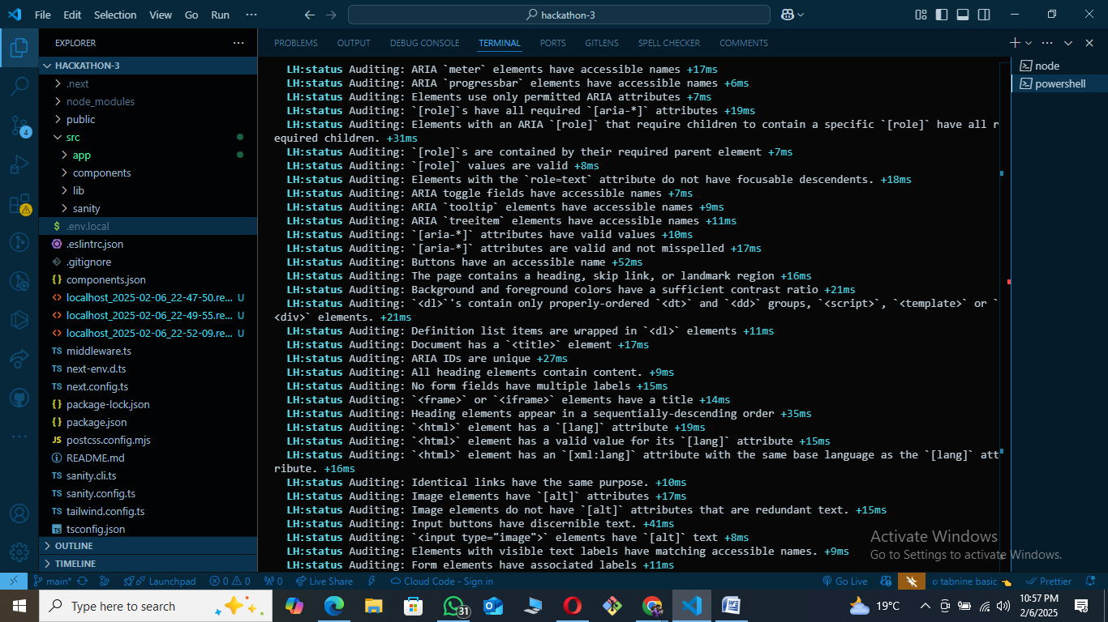

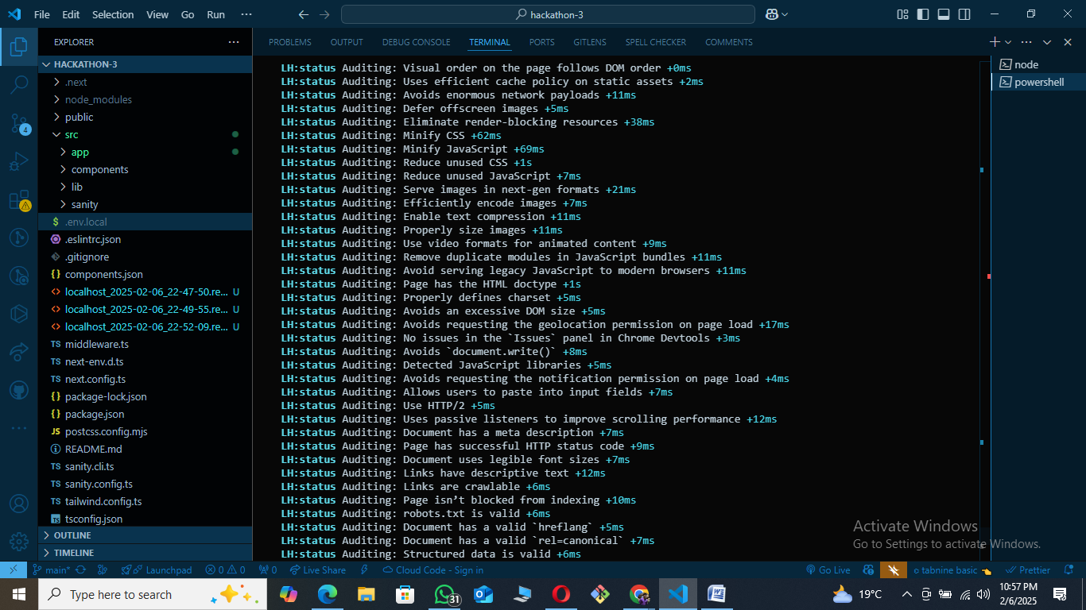

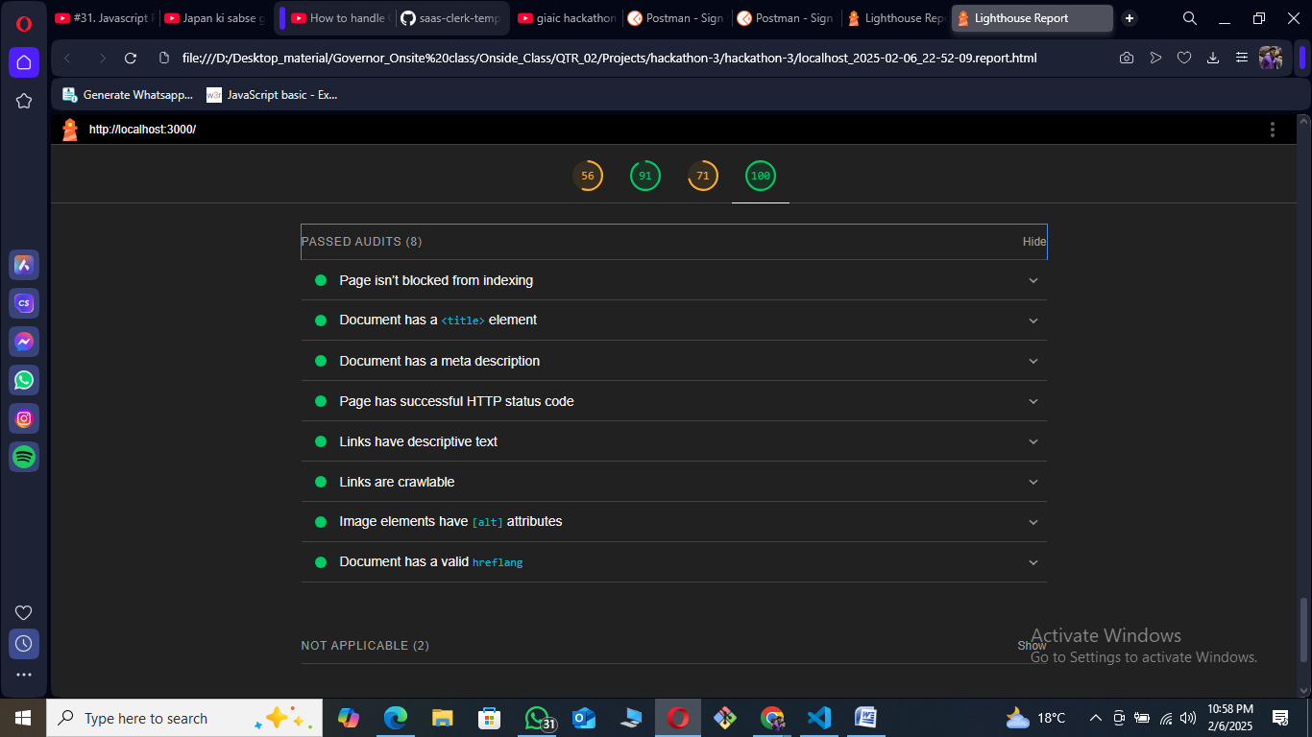

**­­­** 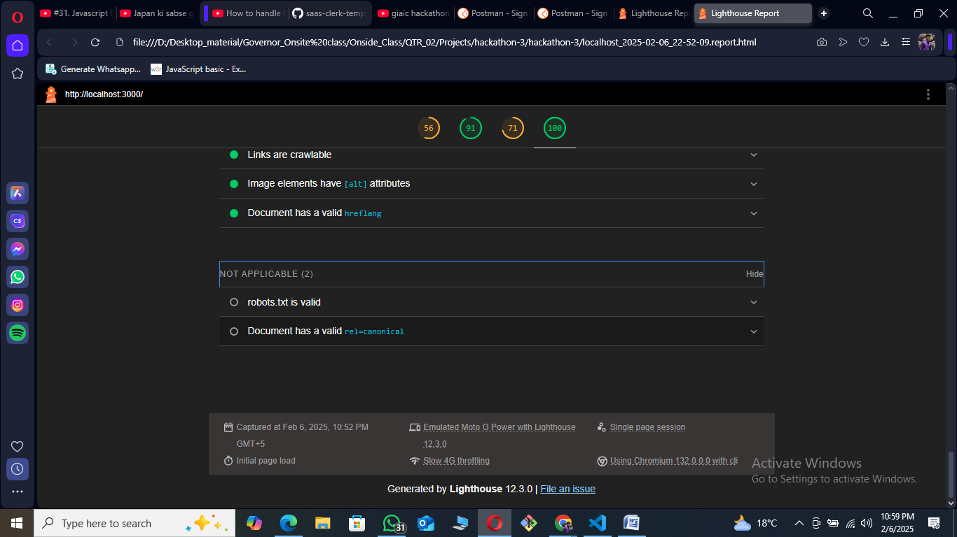

Additional items to manually check (1)

Hide

Structured data is valid

Run these additional validators on your site to check additional SEO best practices.

Passed audits (8)

Hide

Page isn’t blocked from indexing

Document has a <title> element

Document has a meta description

Page has successful HTTP status code

Links have descriptive text

Links are crawlable

Image elements have [alt] attributes

Document has a valid hreflang

Not applicable (2)

Hide

robots.txt is valid

Document has a valid rel=canonical

* Captured at Feb 6, 2025, 10:52 PM GMT+5
* Emulated Moto G Power with Lighthouse 12.3.0
* Single page session
* Initial page load
* Slow 4G throttling
* Using Chromium 132.0.0.0 with cli

Generated by **Lighthouse** 12.3.0 | [File an issue](https://github.com/GoogleChrome/Lighthouse/issues)

**Developer Resources:**

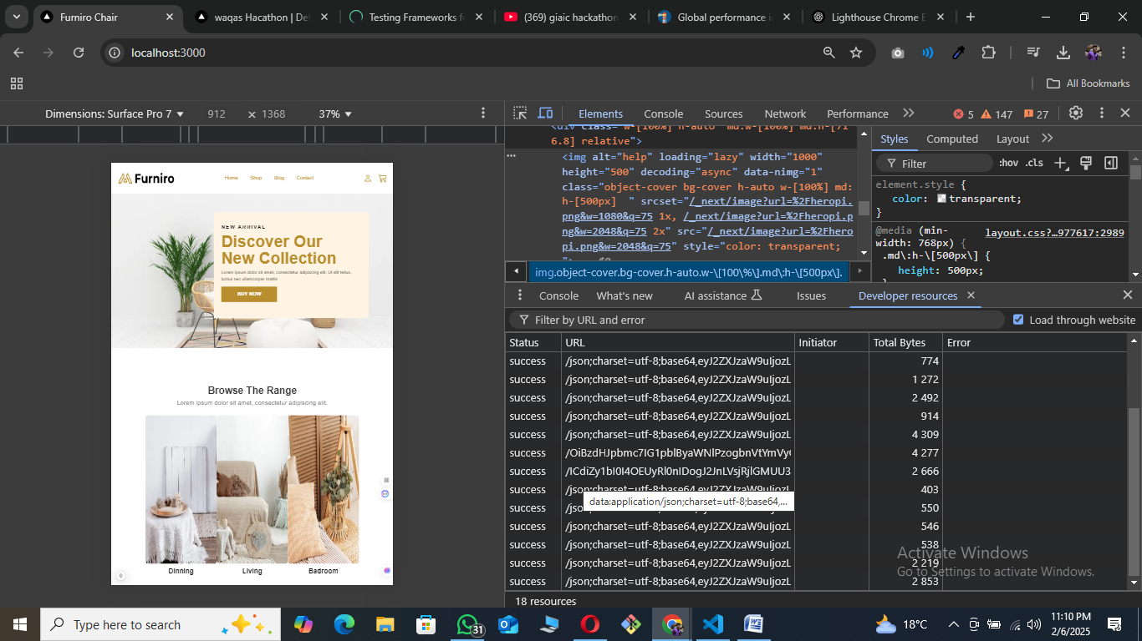

**Performance Monitor:**

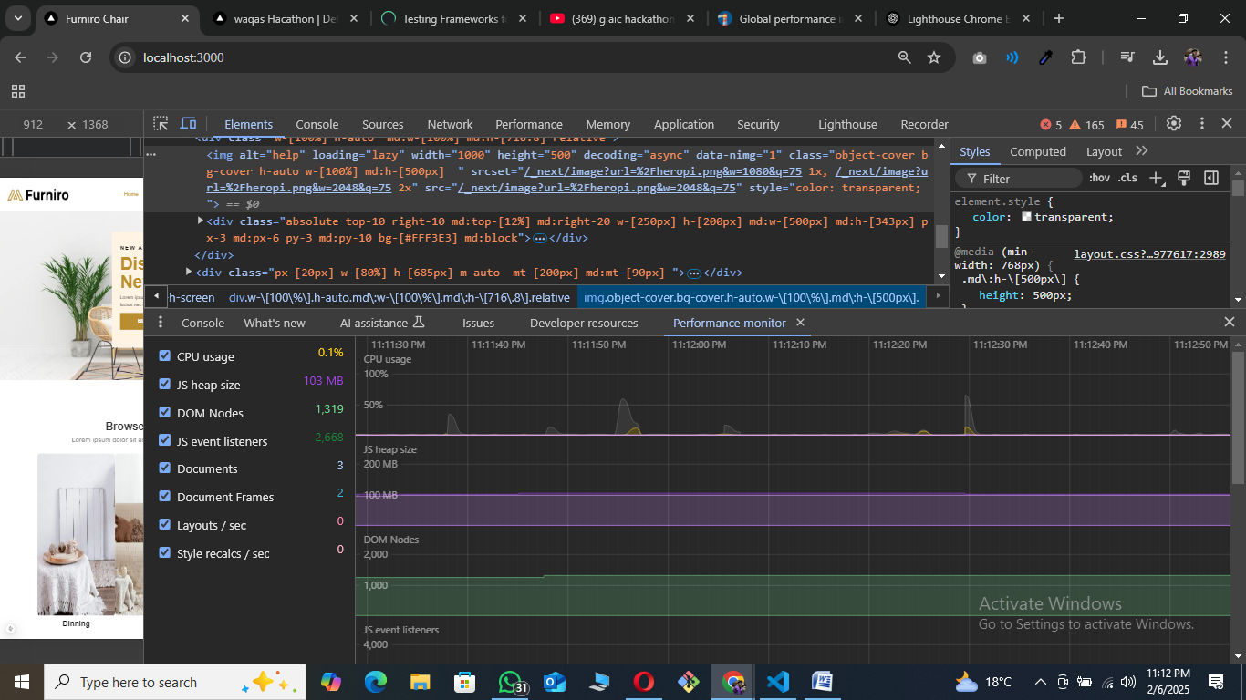

**Security:**

